 | 18.1.3 Editors - Graph Editor - View Menu
Table of content
Graph Editor - View Menu 2
Channels List 2
Sidebar 2
Adjust last Operation 2
Footer 2
Set Preview Range 3
Clear Preview Range 3
Set Preview Range to selected 3
Frame Scene Range 3
Frame Preview Range 3
Zoom In 3
Zoom Out 3
Zoom Border 3
Frame All 4
Frame Selected 4
Go to current Frame 4
Area 4
Horizontal Split 4
Vertical Split 4
Duplicate Area into New Window 4
Toggle Maximize Area 4
Toggle Full screen Area 4
Close Area 4
Pie menus 5
Toggle Dope Sheet 5

Graph Editor - View Menu

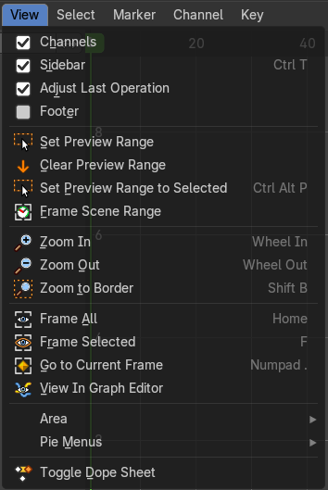
The View menu contains all View related tools.
The content is for all modes the same.

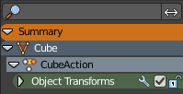
Channels List
Shows or hides the Channels list at the left in the viewport.

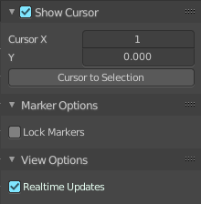
Sidebar
Shows or hides the sidebar at the right in the viewport.

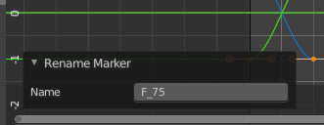
Adjust last Operation
Show the Adjust Last Operation panel down left when you perform a tool.

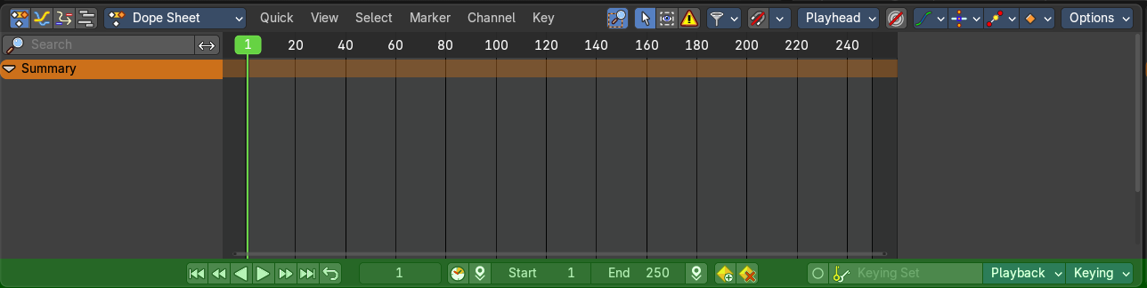
Footer
Reveals the footer.

Set Preview Range
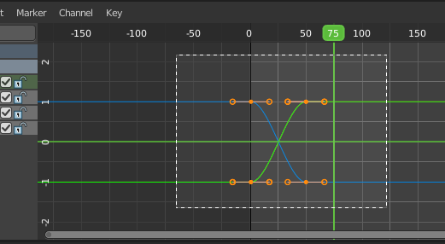
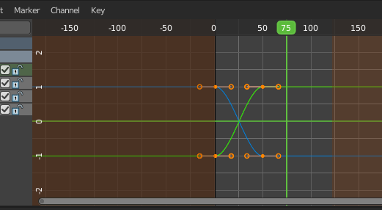
Rectangle select an area of the timeline that gets previewed. The playback now just happens in this marked area.

Clear Preview Range
Clears an existing preview range.

Set Preview Range to selected
Sets the preview range to fit the first and last selected keyframe.

Frame Scene Range
With Use Preview Range off , reset the horizontal view to the current scene frame range.

Frame Preview Range
With Use Preview Range on , reset the horizontal view to the current preview frame range.

Zoom In
Zooms into the viewport.

Zoom Out
Zooms out of the viewport.

Zoom Border
Draws a rectangle and zooms then to fit the size of this rectangle.
Zooming in is done with drawing the rectangle with left mouse button. Zooming out is done with drawing the rectangle with middle mouse button.

Frame All
Zooms in or out in the viewport until all objects in the scene are displayed fitting in the viewport.

Frame Selected
Centers the view at the currently selected keyframe(s).

Go to current Frame
Centers the view at the frame slider.

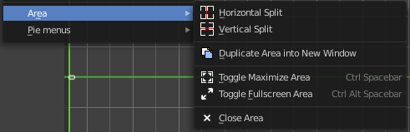
Area
This menu contains general view functionality. And exists in most other editor types too.

Horizontal Split
Splits the current view horizontally into two independent editor windows.

Vertical Split
Splits the current view vertically into two independent editor windows.


Duplicate Area into New Window
Duplicate Area into New Window makes the selected editor window floating. You can then drag it around at the monitor. It is not connected with the rest of the UI anymore.
A separated window cannot be merged into the main window again. You have to close it when not longer needed.

Toggle Maximize Area
Displays the editor maximized with menus.
To return from the maximized view press hotkey ctrl + spacebar. Or reuse the menu item in the area menu.

Toggle Full screen Area
Displays the editor maximized without menus.
To return from the full screen view press hotkey ctrl + alt + spacebar.

Close Area
Closes the area window.

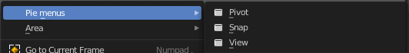
Pie menus
Lists the available pie menus, and gives you the ability to read the hotkeys and assign own hotkeys.

Toggle Dope Sheet
Switch to the Dope Sheet Editor.
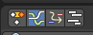
Note that this is a Blender relict. In Bforartists we already have a convenient top level UI menu entry to switch between the editors. We haven't removed this Blender entry for two reasons. It can be hotkeyed. And the entry shows that this Blender functionality exists.

